Anatomy is the study of the structure and relationship between body parts.
Physiology is the study of the function of body parts and the body as a whole.
Anatomical position: The body is erect and the arms are hanging at the sides of the body with the palms forward and the thumbs pointing away.
Superior: Above; at a higher level (towards the head)
Inferior: Below; at a lower level
Anterior: the front; before (Ventral)
Posterior: the back; behind (Dorsal)
Medial: towards the body's longitudinal axis (the middle; mid-sagittal plane)
Lateral: away from the body's longitudinal axis (away from the midline)
Ipsilateral: on the same side of the body
Contralateral: on the opposite side of the body
Caudal: directed toward or situated in or near the tail (buttocks)or posterior part of the body.
Cephalad: directed toward or situated in or near the head or anterior section
Intermediate: between two structures
Proximal: towards an attached base (Heart)
Distal: away from an attached base (Heart)
Superficial: At, near, or relatively close to the body surface
Deep: farther from the body surface
PLANES:
The human body can be divided into various sectors, with the dividing lines represented by planes.
sagittal plane: runs longitudinally and divides the body into right and left portions
midsagittal plane: runs along the midline and divides the body into equal left and right portions.
Parasagittal plane: which is parallel to midline but does not divide into equal left and right portions.
frontal (coronal) plane: runs longitudinally and divides the body into posterior and anterior portions (front and back)
transverse plane: runs horizontally and divides the body into superior and inferior portions( upper and lower)
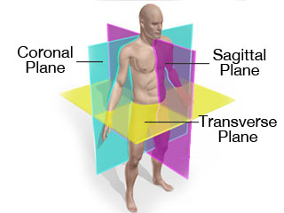

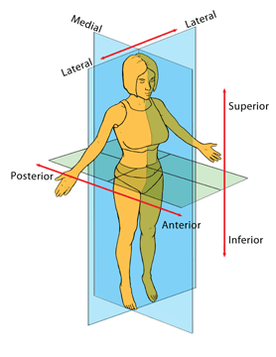

Review:
The shoulders are _________ to the hips.
superior
The feet are ________ to the hips.
inferior
The navel is on the ________ surface of the trunk.
anterior
The kidneys are _______ to the small intestines.
posterior
The heart is ______ to the lungs.
medial
Moving _______ from the nose is the eyes.
laterally (lateral)
The elbow is ________ to the shoulder and wrist.
intermediate
The thigh is _______ to the foot.
proximal
Each foot is ______ to each knee.
distal
The scalp is ______ to the skull.
superficial
The brain is _____ compared to the skull which surrounds it.
Deep
Sagittal plane midsagittal plane Parasagittal plane frontal (coronal) plane transverse plane
A: runs longitudinally and divides the body into posterior and anterior portions (front and back)
B: runs along the midline and divides the body into equal left and right portions.
C: runs longitudinally and divides the body into right and left portions
D: runs horizontally and divides the body into superior and inferior portions( upper and lower)
E: which is parallel to midline but does not divide into equal left and right portions.

